Everything you need to know about
The “1 E & A” Counting System

The “1 E & A” counting system is a set of syllables used to read rhythms. This method can be used to study the rhythms of written music, to accurately transcribe music you hear, to help you sight sing melodies, and so on. There are 13 rules to master in the “1 E & A” counting system.

In simple meter:
1) A note that begins on the beat is called by the number of the beat.
2) A note that begins halfway between two beats is called “&” (pronounced and).
3) A note that begins on the second quarter of the beat is called “E.” (pronounced ee).
4) A note that begins on the fourth quarter of the beat is called “A.” (pronounced uh).
5) A note that begins on the second third of the beat or a division of the beat is called
“trip-.”
6) A note that begins on the third third of a beat or a division of the beat is called “let.”
7) Sextuplets are counted as two groups of three, not three groups of two (1 trip-let &
trip-let, etc.).
8) Quintuplets are counted as one group of five (1 quin-tu-pl-et 2 quin-tu-pl-et etc.). Example:
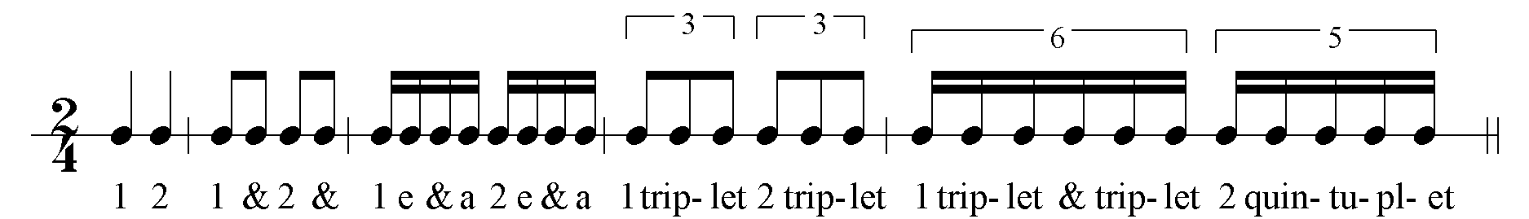

In compound meter:
9) A note that begins on the beat is called by the number of the division within the measure (1, 4, 7, 10).
10) A division of the beat is also called by the number of the of the division within the measure (2, 3, 5, 6, 8, 9, 11, 12)
11) A note that begins halfway between two divisions (a subdivision) is called “&” (pronounced and).
12) A note that begins on the second third of the division is called “trip-.”
13) A note that begins on the third third of a division is called “let.”
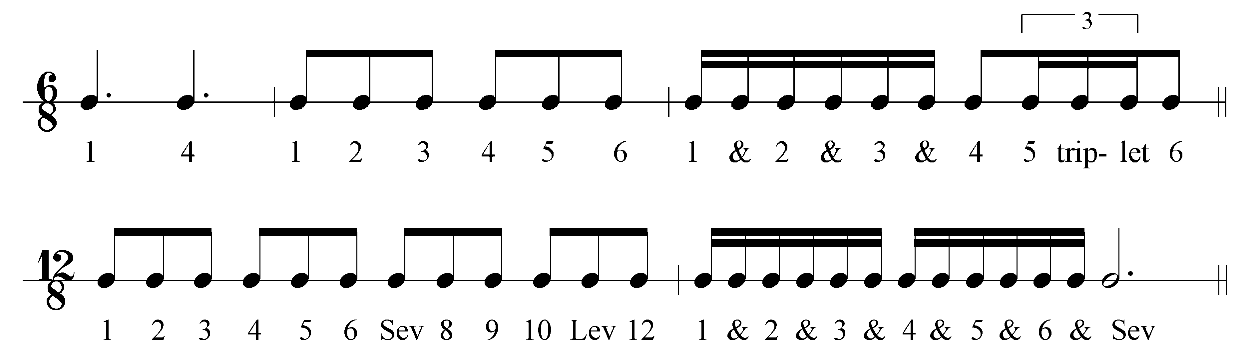

The “1 E & A” Counting System continued

This system actually has more syllables than the “Eastman” counting system, but addresses more of the possible subdivisions of a beat. Unlike the Eastman system, this system makes a
distinction between a triplet subdivision in simple meter and the comparable subdivision in compound meter. In the Eastman system, each quarter of a beat and third of a beat has a distinct syllable. However, quintuple and sextuple subdivisions are all assigned the syllable “ta.” It may take the student longer to memorize all of the syllables presented here, but the authors believe that the students will find these syllables much more expedient.

Exercises:
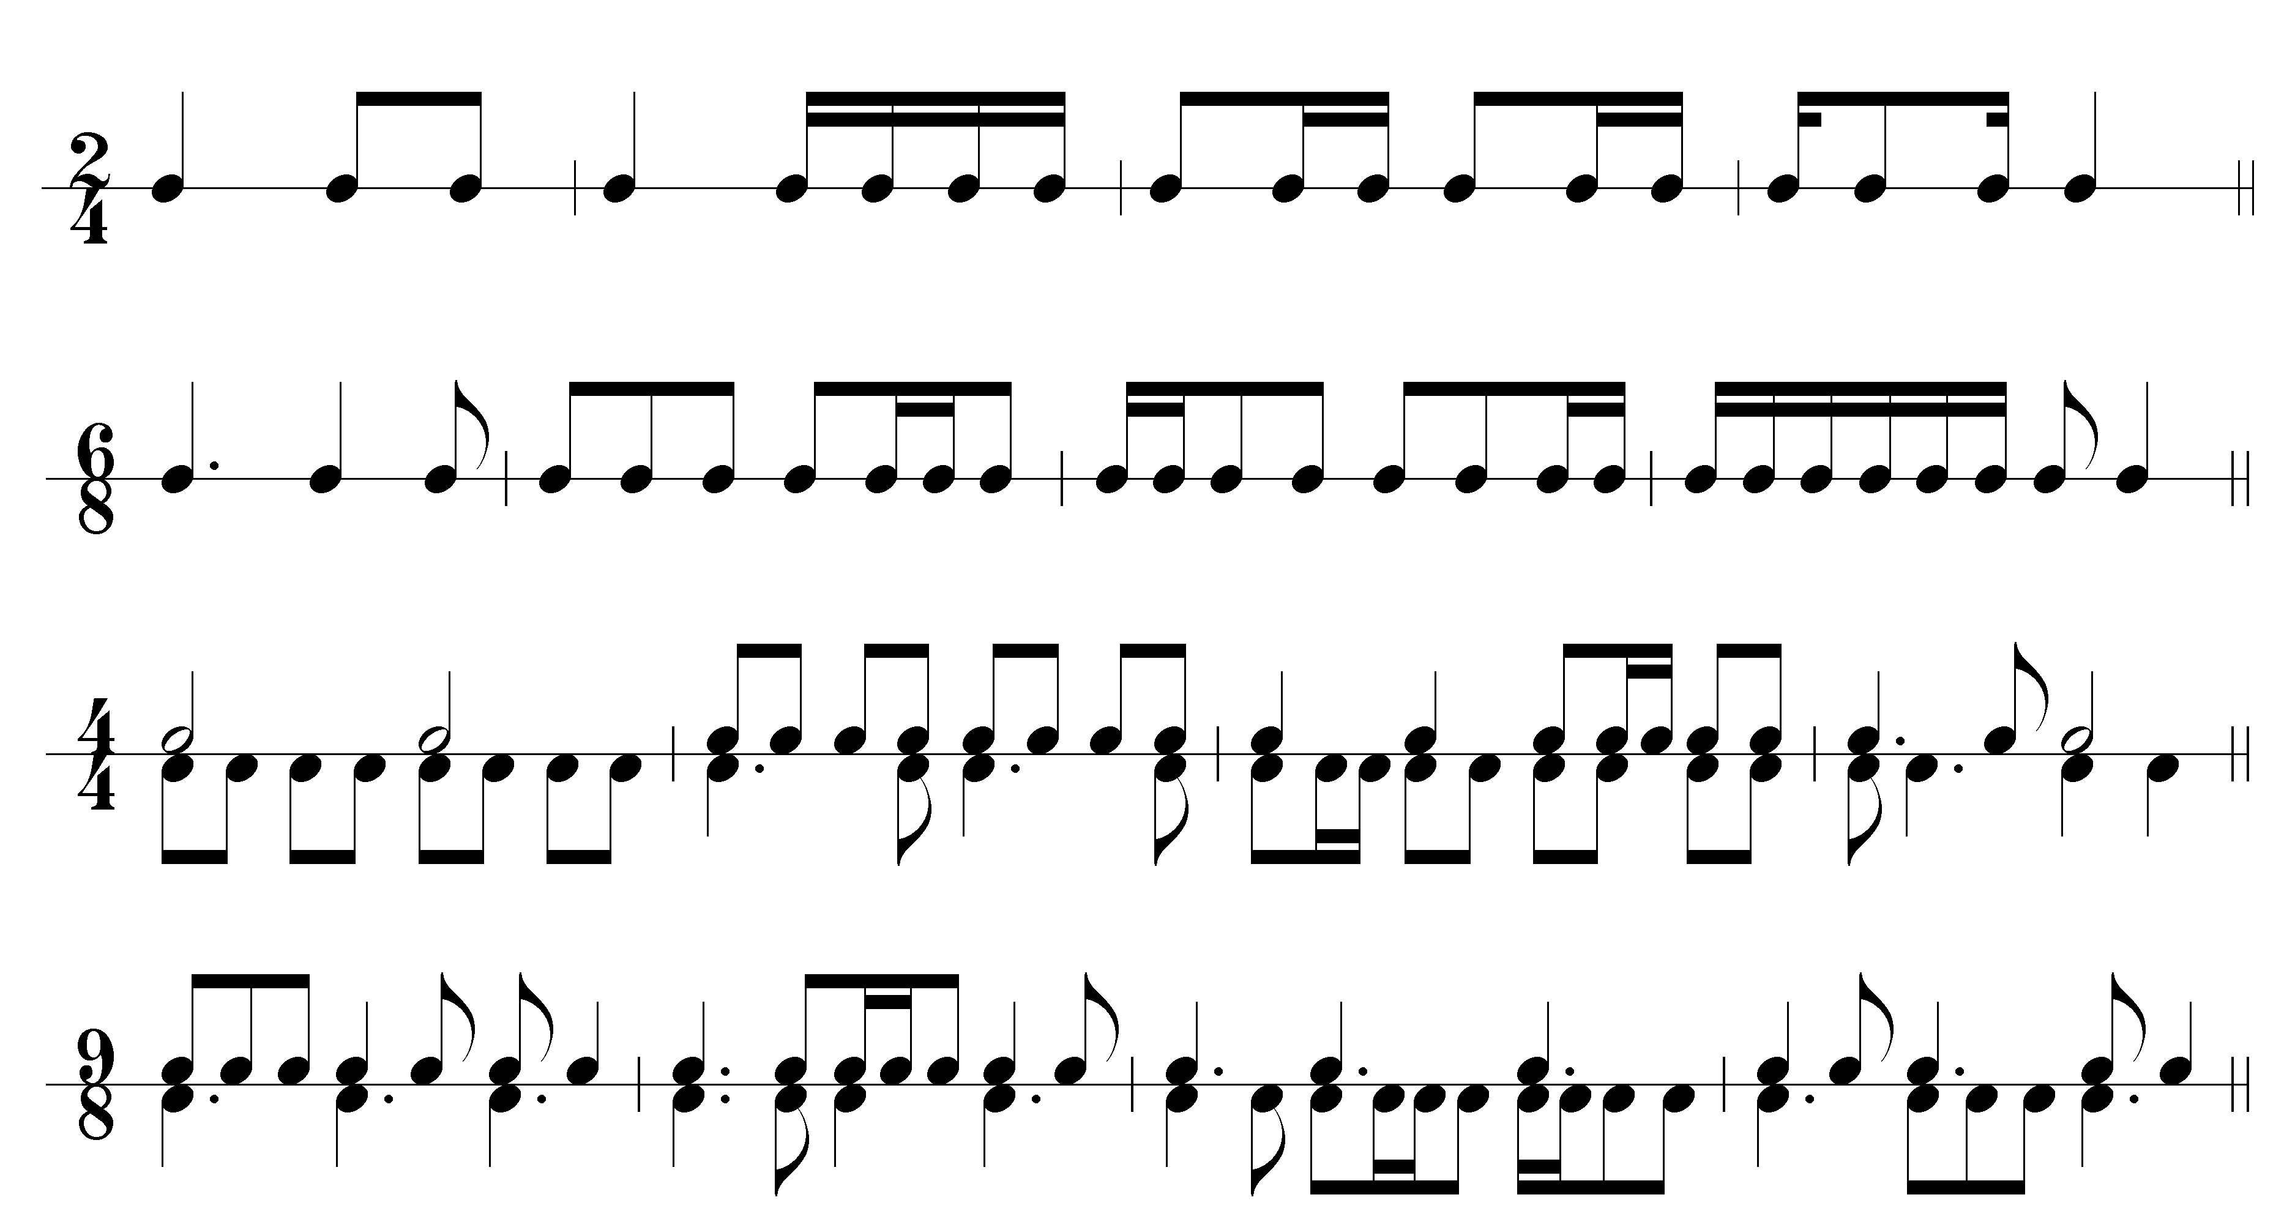

2

